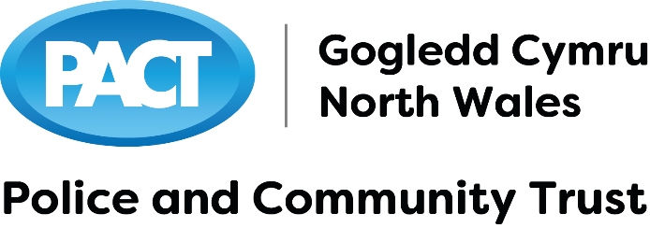

Since 1998 PACT has invested over £2,000,000 in over 2,500 projects and 2023 sees us celebrating 25 years of supporting communities across North Wales.
PACT encourages applications from community and voluntary groups in partnership with their Neighbourhood Policing Teams that will have a positive impact in our communities and encourage a safer environment and increased quality of life focussing on initiatives that:
- Promote crime prevention programmes
- Increase awareness of substance mis-use
- Reduce crime and protect people and property
- Promote road safety
- Improve relations between young and elderly
- Provide support to Safer Neighbourhood Policing Teams
- Enhance appreciation of the police and their involvement in local issues
- Work in partnership with a wide variety of public, private and third sector organisations
If you would like to work with us you can find out more at:
www.pactnorthwales.co.uk
or contact 01745 588516

Title/Content of presentation:
Presenters: Ashley Rogers (Chair of Trustees); Dave Evans (Project Manager)
Supporting our Communities
Supporting our Communities

Since 1998 PACT has invested over £2,000,000 in over 2,500 projects and 2023 sees us celebrating 25 years of supporting communities across North Wales.
PACT encourages grant applications from community and voluntary groups working in partnership with their Neighbourhood Policing Teams on projects have a positive impact in our communities and encourage a safer environment and increased quality of life focussing on initiatives that:
• Promote crime prevention projects
• Increase awareness of substance mis-use
• Reduce crime and protect people and property
• Promote road safety
• Improve relations between young and elderly and encourage community cohesion
• Work in partnership with a wide variety of public, private and third sector organisations

