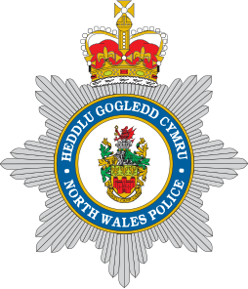

A joint initiative of
The Police and Crime Commissioner for North Wales and
North Wales Police



The Community Partnership Fund for North Wales 2023

Supporting projects that prevent and reduce crime and anti-social behaviour
“Criminals pain – Communities gain”

APPLICATION PACK

In association with

North Wales Police and Community Trust

Registered Charity Number 1071628

Police and Crime Commissioner and North Wales Police
Your Community Your Choice

Introduction by Police and Crime Commissioner Andy Dunbobbin and
Assistant Chief Constable Chris Allsop, North Wales Police

Once again, we are delighted to invite community organisations to submit applications to our annual
‘Your Community, Your Choice’ community fund.

This will be the tenth year of ‘Your Community Your Choice’ and, to celebrate this, we are making
£120,000 available to support communities across North Wales that aim to prevent crime, keep our communities safe and support our Police and Crime Plan. Because of this increased funding, we have three tiers of grants available to apply for - £2,500, £5,000 and £10,000 – that we believe will support local grass-roots projects, and those working across counties.

We particularly want to see proposals that help our local communities work with our local policing teams to develop or support existing projects that help to prevent crime and anti-social behaviour in our communities. The value of partnership working cannot, and should not, be underestimated and community groups such as yours bring great value to local projects. In many cases volunteers are
the backbone of our society and this fund aims to support that work.

Our focus with this fund continues to be supporting and developing resilient communities. Community organisations have a vital role to play in making this happen by supporting the priorities in our Police and Crime Plan. We are encouraging community organisations to apply for funding for projects that will have a positive impact – particularly those which have a
long-term vision reflecting the diversity of our area and which work in collaboration with others to prevent problems occurring.

When developing your proposal please consider how it will support the priorities of the current Police and Crime Plan which can be found on the Police and Crime Commissioner’s website: https://www.northwales-pcc.gov.uk/what-our-priorities-are-and-how-we-are-doing

Our three policing priorities are:

• Delivering Safer Neighbourhoods

• Supporting victims and communities

• Fair and effective Criminal Justice System

The public will once again decide on which proposals are successful through our usual online voting portal. So, if your application is accepted you will need to ensure that your network of supporters get voting for you.

‘Your Community, Your Choice’ is a joint initiative that has been made possible with funding from the Police and Crime Commissioner, together with money made available through assets seized from criminals under the Proceeds of Crime Act. This would not be possible without the dedication and commitment of the oﬃcers and staff of North Wales Police working tirelessly to bring criminals to justice, and applicants are expected to discuss their idea/application with their local policing team.

We are delighted that our partners at the Police and Community Trust (PACT) led by chair, Ashley Rogers, and his team are once again working with us to deliver this year’s fund. 2023 represents the 25th Anniversary of PACT in North Wales and it is fitting that PACT continues to deliver Your Community Your Choice in this special year.

Thank you very much for your interest, we wish you every success with your application.

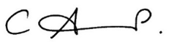

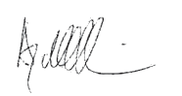Andy Dunbobbin
Police and Crime Commissioner for North Wales
Chris Allsop
Assistant Chief Constable

Please note the following Application Criteria and Guidelines:

1. ‘Your Community, Your Choice’ aims to support local community groups/organisations with funding, decided by a public vote, to develop new or existing projects that help to improve the quality of life in local communities.
All proposals are expected to support the current Police & Crime Plan, and encourage the development of positive working partnerships that help to support the current Police
and Crime Plan (2021-24). You can find the current Police and Crime Plan at: www.northwales-pcc.gov.uk
2. Maximum amount of application
a) £2,500.00 for individual County applicants (Anglesey, Conwy, Denbighshire, Flintshire, Gwynedd, Wrexham)
b) £5,000.00 for larger projects in each county
c) £10,000 for projects that work across Gwynedd & Anglesey; Conwy and Denbighshire;
and Flintshire and Wrexham.
3. Applicants must be a properly constituted voluntary organisation, community group or charity working in North Wales. Town and Community Councils are also eligible but MUST show evidence of appropriate matched-funding and applications MUST come via Clerk and Chair to the Council.
Please note: you may be asked to provide a copy your most recent set of accounts and/or most recent bank statement.
4. Applicants should indicate:
a) How your project will contribute towards reducing crime and anti-social behaviour in your area and support the priorities set out in the current Police and Crime Plan.
b) Tell us how you have evidenced the need for your project and the problem that you are seeking to address.
c) The benefits which the project will bring to your local community. d) Who will benefit from the project.
e) Ages of people involved in your project.
f) Partners/agencies involved in/supporting your project.
g) Applicants MUST discuss their application with the local policing team and receive the support of the district Inspector before submission.
h) Applications for CCTV will not be considered
5. Application must include a full financial breakdown, giving specific details of how the funding will be spent – e.g. equipment, travel, staff costs etc. Please indicate if you have obtained, or are in the process of obtaining, any match-funding.
6. If any young people involved in your project are aged under eighteen, the group must have the support of adults and appropriate vetting procedures have been carried out. Please confirm in your application that this has been obtained.
7. Previously successful applicants can apply but their proposal must be for a new and innovative piece of work.
8. If you wish to discuss your idea, please contact Dave Evans on 01745 588516 or by email to:
yourcommunityyourchoice@northwales.police.uk
9. Decisions of the panel and voting public will be final. No correspondence about unsuccessful applications will be entered into. A maximum of four votes per household/ISP address will be allowed per project.
10. Closing date for applications: 12.00 noon, 3rd February 2023
11. Projects must be completed, and grant monies spent, by 30th September 2023
12. Successful applicants will be required to sign and return our standard Terms and Conditions
(Appendix A)
13. Please return the completed application form by Email to:
yourcommunityyourchoice@northwales.police.uk
Or by Post to:

North Wales Police and Community Trust, PACT Oﬃce, Ffordd William Morgan, St. Asaph Business Park, St. Asaph, Denbighshire, LL17 0HQ

Your Community, Your Choice 2023

Grants:

County applicants:

a) Maximum amount of grant application £2,500.00

Three groups in each county with the most votes will be successful

Larger County projects

a) Maximum amount of grant application £5,000.00

One project per county with the most votes will be successful

Area Projects

a) Maximum amount of grant application £10,000.00

Three groups working across each of the following joint areas will be successful: Gwynedd and Anglesey; Conwy and Denbighshire; Flintshire and Wrexham

Timetable

(Dates may be subject to change)

Application period:  Opens  Closes | 09.01.23  03.02.23
Application assessments: | Week commencing 14.02.23
Notiﬁcation to applicants of decisions: | Week commencing 21.02.23
Public Internet Voting Period:  Opens  Closes | 27.02.23  17.03.23
Notiﬁcation to Successful Applicants:  Cheque presentation event to successful applicants.  To be held at White House Hotel, Rhuallt, Denbighshire | Week commencing 24.03.23  29th March 2023

Please Note: Applicants will be advised should any dates change.

APPLICATION DETAILS

1. Organisation:

2. Address (including post code):

3. Contact Details

Name:
Position in organisation:
Email:
Telephone:
Mobile:

4. Title of Project:

5. Amount applied for:

6. Is this request for:

Part/Match-Funding:

Total Funding:

7. Please describe your organisation:
a) (If a Registered Charity or Community Interest Company please give your registration number)

b) When was your organisation formed

c) How many members are there on your committee/Board of Trustees?

d) How many people are needed to authorise a payment or sign a cheque?

e) If successful with this application please advise who our cheque should be made payable to:

8. Your project:

Please describe the activities or services you are seeking funding for AND what problem you are seeking to address Please tell us what difference your project will make to your community, the problems it aims to overcome and how it will help to strengthen resilient communities (Please indicate the outputs and outcomes your project will achieve) (MAX 500 words)

9.Please tell us which current Police and Crime Plan priority your project aims to support and how it will do this: (MAX 500 words)

10.How have you identified the need for this project? (Please include evidence) (MAX 500 words)

11. Where will your project take place?
(Please also indicate the County or for pan-North Wales applicants, please confirm the areas and counties you will be working in)

12. When will the project take place?
(Please indicate start/end dates)

13. How many people will be involved in the delivery of your project?
(Please include age-ranges)

14. How many people do you anticipate will beneﬁt from your project?
(Please include age range)

15. Does your project address the needs of any particular group?
(Please indicate how)

16. You will need to discuss your project with your local Neighbourhood Policing
Team, and obtain the support and endorsement of your District Inspector.
Tell us how you will work with your local policing team in the delivery of your project. Please confirm details of discussions including oﬃcers concerned Your proposal will require the support of your district police Inspector – Section 17. (Max 200 words)

17. District Inspectors Comments/Endorsement

18. Working in Partnership: Please indicate which other partners/agencies will be involved in your project and their roles.

19. Please tell us how you will monitor and evaluate your project (Max 200 words)

20. If your application is successful, what will happen to your project after this funding has been utilised? (Max 200 words)

21. Project Costs

Please give a full breakdown of all costs. Please include approximate value of any in-kind support obtained. Please indicate which items our funding would be used for.

Item | Cost
TOTAL | £

22. Have you secured funding from any other funder(s). If so, please indicate to whom, how much you have received.

FOR APPLICANTS APPLYING FOR A GRANT OF £5,000 or £10,000

23. Please tell us which counties you will be working in and your organisation's ability to deliver your proposal and the structure in place to support local communities. (Max. 300 words)

APPENDIX A

The following Terms and Conditions will apply to all successful applicants
This document must be signed and witnessed and returned prior to any funding being received.

TERMS AND CONDITIONS FOR PROJECT FUNDING
1. The ‘Project’ means the project or activity that the Funder has agreed to give you a grant for as set out in your application form together with any supporting documents such as budget information, a timetable and any other documents that set out how your Project will be managed.

2. The ‘Funder’ means jointly the Police and Crime Commissioner for North Wales and
North Wales Police

3. ‘You’ means the organisation that the Funder has given a grant to.

4. The grant may only be used for the Project.

5. You must start the Project within one month of receiving the grant payment from us.

6. You must make satisfactory progress with the Project and complete it on time.

7. You must tell us immediately if anything threatens to curtail or delay the Project.

8. You must tell us if you receive any other funding for the Project from any other source at any time during the Project. If this means that you no longer need the funding from us, you must pay the grant back to us immediately upon demand from us.

If you spend less than the whole grant on the Project, you must return the unspent amount to us promptly. If the grant part-funds the Project, you must return the appropriate share of the unspent amount to us.

9. You must write to us as soon as possible if any legal claims are made or threatened against you and/ or which would adversely affect the Project during the period of the grant (including any claims made against members of your governing body or staff concerning the organisation).

10. If you are an unincorporated group, you must provide us with written evidence that the person signing below has the authority of the group to enter into the Grant Agreement on behalf of all the members of the group and that all members of the group will be jointly and severally liable under the Grant Agreement.

11. You must tell us in writing as soon as possible of any investigation concerning your organisation, trustees, directors, employees or volunteers carried out by the Police, Charity Commission, HM Revenue & Customs or any other regulatory body.

12. In carrying out your Project, you must meet all laws regulating the way you operate, the work you carry out, the staff you employ or the goods and services you buy. For example, you are responsible for getting any licences, permissions and insurances that are necessary by law.

13. A clear financial summary, which shows how the grant has been spent, shall be compiled and supplied to the Funder. All invoices, receipts and accounting records relating to the expenditure of the grant
will be made available at any reasonable time for inspection or audit by the Funder.

14. A simple record of the project’s development, supported by photographs, should be maintained and will be made available at any reasonable time for inspection by an oﬃcial of the funder.

15. You are required to contact the North Wales Police Press and Media Department and provide details of the initiative PRIOR TO ANY EVENT ASSOCIATED WITH THE PROJECT.

Press releases and all publicity material MUST always include reference to the financial support provided by: The Police and Crime Commissioner for North Wales and North Wales Police.

16. You must ensure that all reasonable steps have been taken to ensure that any adult assisting with the project has successfully complied with the relevant security and safety checks if working with children and young people.

17. The Funder is purely a grant-making organisation and is not responsible for any acts or omissions of those taking part in the projects and schemes. Such responsibility rests with those who organise the projects and schemes. You are required to consider carefully your legal responsibility as organiser and to take out any insurance cover considered by you to be appropriate.

We may recover the grant in our absolute discretion, if any of the following events occurs:

17.1 you close down your business (unless it joins with, or is replaced by, another business that can carry out the Project and we have provided our prior written permission);

17.2 you make any changes to the Project without first getting our written permission;

17.3 you use the grant for anything other than the Project;

17.4 you do not follow our reasonable instructions;

17.5 you do not carry out the Project with reasonable care, thoroughness, competence and to a standard that would be expected for your level of experience in your artistic practice, profession or line
of work;

17.6 you do not complete the Project;

17.7 you have supplied us with any information that is wrong or misleading, either by mistake or because you were trying to mislead us;

17.8 you are declared bankrupt or become insolvent, any order is made, or resolution is passed, for you to go into administration, be wound up or dissolved; an administrator or other receiver, manager, liquidator, trustee or similar oﬃcer is appointed over all or a considerable amount of your assets; or you enter into or propose any arrangement with the people you owe money to;

17.9 you act illegally or negligently at any time, and we believe it has significantly affected the Project, or is likely to harm our or your reputation; and/or

17.10 without first getting our approval in writing, you sell or in some other way transfer the grant, your business or the Project to someone else.

18. These terms and conditions and the Grant Agreement remain in force for whichever of these is the longest time:

• for one year following the payment of the last instalment of the grant;

• as long as any part of the grant remains unspent;

• as long as you do not carry out any of the terms and conditions of the Grant Agreement or any breach of them continues (this includes any outstanding reporting on grant expenditure or Project delivery.

19. The Freedom of Information Act 2000 (‘the Act’) applies to us. This means that any information you give us could be released to any person who asks for it under the Act. You must tell us if you think that any of the information should be confidential under any of the exemptions of the Act. Please visit www.ico.gov.uk/ for information on the Act.

PROOF THAT THESE CONDITIONS HAVE BEEN COMPLIED WITH MAY BE REQUIRED.

Name of Organisation …………………………….................................……....................................................................................................................................................................... (PRINT FULL NAME) I …………………………….................................……....................................................................................................................................................................... have read the above terms and conditions and on behalf of the project team agree to abide by them.

Signed: …………………………….................................……................................................................... Date: …………………………….................................……..............................................

(PRINT) Position in organisation: …………………………….................................…….........................................................................................................................................

Witnessed by: (Signature) ……………………………...................................….….......................................................................................................................................................... (PRINT) Full Name: ………......…………………….................................…….......................................................................................................................................................................... (PRINT) Position in organisation: ………......…………………….................................….....................…..............................................................................................................

PLEASE RETURN THIS SIGNED DOCUMENT TO:-

North Wales Police, PACT Oﬃce. Ffordd William Morgan. St Asaph Business Park. St Asaph. Denbighshire. LL17 0HQ

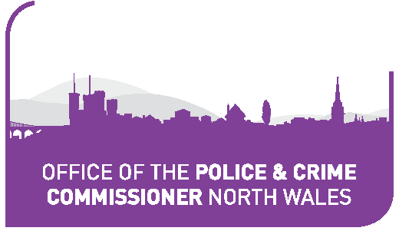SWYDDFA COMISIYNYDD HEDDLU A THROSEDD GOGLEDD CYMRU

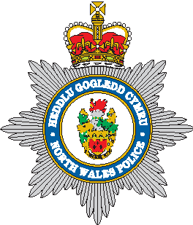I HEDDLU
GOGLEDD CYMRU

NORTH WALES
I POLICE

86735.

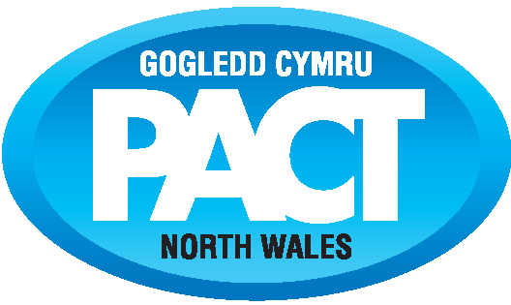In association with

North Wales Police and Community Trust

Registered Char ity Number 1071628

