COVID 19 Wellbeing Support for Affiliated Organisations

Coronavirus - Maintaining a Healthy Mind

Feeling anxious yourself about coronavirus and how it will affect you and your family |  | 
 | Advice and Tips
- Stay in touch regularly with family and friends by phone / internet / social media etc.;
- If you’re self-isolating then create yourself a new daily routine that prioritises looking after yourself and doing things that you enjoy;
- Try and see any positives in self-isolation such as having the time to read a book or start a new hobby;
- Try to avoid speculation by referring to trusted sources of information such as Public Health Wales and Gov.uk;
- Acknowledge any feelings of vulnerability, anxiety or distress as these feelings are normal in the current situation;
- Make sure that you are looking after your physical and mental health by exercising, eating healthily, stretching, paying attention to your breathing, relaxation exercises and ensuring you have time to rest;
- Make sure that you get some fresh air each day if possible;
- Bear in mind that everybody reacts differently in response to a pandemic – you may experience a change in your eating or sleeping pattern, or difficulty concentrating;
- If watching the news is causing stress or anxiety, try to limit your news intake and achieve a balance of being informed but not overwhelmed;
- Consider your social media feed – is anyone you’re following causing you anxiety by the way they are talking about coronavirus? If so, consider temporarily unfollowing them;
- Let people know if you feel uncomfortable having a discussion about coronavirus so you can opt out;
- Focus on the things that you can control;
- Read our self-help factsheet about anxiety:
 | Relevant Support Services
Every Mind Matters – an organisation created by Public Health England to help you manage and maintain your mental health (https://www.nhs.uk/oneyou/)
MIND – read information about coronavirus and your wellbeing (https://www.mind.org.uk/information-support/coronavirus-and-your-wellbeing/)​
SHOUT - NEW free 24/7 crisis text line, providing support for anyone, anytime, anywhere in the UK, whatever their crisis. (Text SHOUT to 85258 or find details at: https://www.crisistextline.uk/)

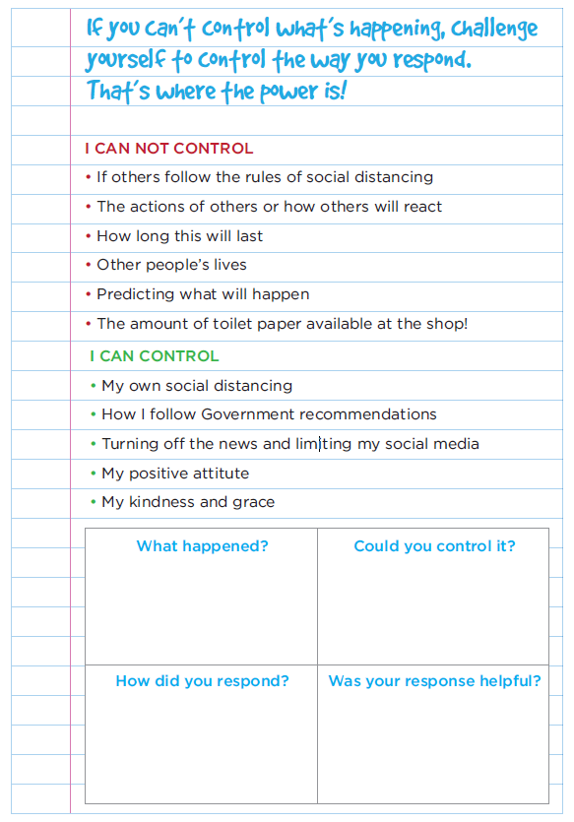
Pandemic Anxiety 101 – Why We Are Doing Weird Stuff
– by Imogen Wall
https://cofeworcester.contentfiles.net/media/assets/file/Coping_with_stress_and_lockdown.pdf
As humans we can all unite in the fact that we are all feeling a bit ‘wobbly’ at the moment. Many of us are experiencing reactions that we do not really understand. Here is a post written by Imogen Wall (a mental health first aider / therapist) that I’m sure we can all relate to…
IN CRISIS, WE START DOING WEIRD STUFF:
For example, over the last week some of us have struggled to sleep, stayed up late into the night reading endless news articles, bought pasta that we don’t even like very much, became angry at our family members for not staying at home, and drank more than usual. I have been a bit teary, and all I want to do is eat cake, cake and more cake.
If you’re having a ‘wobble’ you may also have noticed all sorts of weird stuff going on. Are you arguing more, talking faster, struggling to sleep, restless, desperate for information? Or are you teary and overwhelmed, perhaps feeling a bit sick? Struggling to make decisions? Just want to stay in bed? Tummy upsets? Having palpitations, butterflies, headaches? Ranting, picking fights or getting into arguments? Laughing unexpectedly or saying random, inappropriate things? Developing very strong opinions on epidemiology overnight? Or have you just completely gone to ground?
If you are feeling any of these things: good news! You are not going mad. And you are 100% not alone. You are, in fact completely normal: a fully emotionally functional human being. Congratulations! Why? I’ll explain…
WE ARE LIVING IN TURBO-ANXIOUS TIMES:
We’re in the middle of an unprecedented crisis that has shown up unexpectedly (they do that) and which presents a mortal threat to ourselves, our loved ones and our way of life. It’s terrifying and it’s getting worse and it makes us feel totally out of control. And this is on top of everything else we have going on.
HERE’S THE SCIENCE BIT:  When we are exposed to threats and need to deal with them, our brain springs into action. Specifically a tiny, almond looking thing is buried behind your ear and it’s called the amygdala. It’s the bit in charge when we are frightened and right now, it’s in full tin-hat klaxon mode. Unfortunately, the amygdala is a very ancient bit of kit. It came into being when threats consisted of being eaten by large, scary animals such as bears. It is very basic; it only really has two settings… ‘no bear’ and ‘BEAR!!!’. | 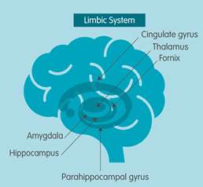


SETTING: BEAR!!!
Because all threats look like a bear to the amygdala, it preps you accordingly. There are really only two reactions to a bear about to eat you: fight it, or run away really fast. This is called the fight or flight response (there is also freeze, where you become paralysed). It does this by flooding your body with chemicals like cortisol and adrenaline. Your heart rate goes up, you feel super alert, your breathing goes shallow, your muscles are ready for action. These chemicals are also largely responsible for the huge range of other cognitive/physical/emotional reactions mentioned earlier. In a group fear situation like a pandemic, this tends to happen whether you think you’re scared or not – anxiety is even more infectious than COVID. Your body reacts even if your conscious mind doesn’t.
BEAR vs VIRUS:
Obviously, this is all great if you are running away from a bear. But now we’re in a situation where we’re being asked to do the EXACT OPPOSITE of running away. We are being told to sit tight. Literally stay still. Process large amounts of information, make complicated and life changing decisions, and stay calm. All while a bit of your brain is running around yelling ‘BEAR!!!’. This isn’t easy. The result is an awful lot of stress and anxiety. You end up feeling really overwhelmed and having all sorts of reactions.
SIGNS AND SYMPTOMS
Anxiety isn’t just mental – it’s also physical, cognitive and behavioural. You will notice all kinds of things: stomach upsets, headaches, insomnia, changes to eating, changes to the way you talk. It’s also cognitive: it’s very difficult to think straight when you’ve got the ‘BEAR!!!’ thing going on – so we all become very bad at making decisions, absorbing information and generally thinking rationally. Which is exactly what we need to do.
SO WHAT TO DO:
Well, the good news is it is possible to calm down. We can turn the amygdala from ‘BEAR!!!’ to ‘no bear’ and not just by distracting it with cake and tea. Here are some solid, scientifically proven things you can do:
Breathe. It’s so basic, but breathing exercises are basically magic. They work in minutes and you can do them anywhere. They work because of all the physical reactions the amygdala triggers; rapid breathing is the only one over which we have conscious control. Control your breathing and you are basically telling your body: it’s OK. There is no bear. Your body will then start to dial down the adrenaline and cortisol and all the other reactions will slow to a halt.
How to control your breathing? It’s easy – and if you want help, search ‘two minute breath bubble’ into YouTube. The golden rules are:
- Make the outbreath longer than the in breath.
- Imagine there’s a candle in front of you and it mustn’t go out.
- Breathe from the tummy.
- Do it for two minutes. Time yourself. See how you feel.

Seriously, try it. This technique is used by everyone from top athletes to the US military to help stay in control while under stress.
Call A Friend:
Don’t suffer alone. Call a mate – someone who will listen to you while you have a bit of a rant, or a cry, or a general wobble. Someone you can trust not to judge you and who’ll just sympathise. And if you get one of those calls, just be nice to them. You only need to be kind. You can’t fix what’s going on so just give them a bit of space to rant and tell them they’re normal and doing great. And if you’re OK, call your friends and check in on them… especially if they’ve gone silent.
Laugh:
It doesn’t matter what is funny – laughter is a huge releaser of endorphins. Silly ‘memes’, silly jokes, stand-up, rolling around with your kids, video’s on YouTube. The sillier, the better. This is also very good for bonding with friends, which will also make you feel less alone.
Do Something With Your Hands:
Yes you can meditate if it’s something you enjoy, it’s great. But if it’s not, then trying to start when you’re already anxious is really hard. Instead, do something with your hands that you have to focus on to get right. For example, cook, tidy, knit, draw, bake, garden, mend things. These are mindful activities.
Treat Your Body:
We hold stress in our bodies at least as much as our minds. Take a bath or a shower. Put things that feel good on your skin. Use nice smelling body creams. Stretch. Skip. Do yoga. Dance. Eat healthy but delicious things – fresh if you can access it. All of these will help calm you down.
Sunshine:
It’s springtime amid this horror – enjoy it. If you can’t go outside, open the windows and feel it on your face and breath. If it’s safe for you to go outside (maybe you live in the country) do it, while of course observing social distance. Go for a walk – being outdoors, connecting with nature, is hugely calming.
Step Away From Social Media / The News:
All it will do is scare you more and make things worse. Turn off the telly and AVOID Twitter. Stick to sensible sources like the BBC and the NHS. Limit yourself to short need-to-know bits a day. You’ll immediately feel better.
Step Away From Terrible Coping Mechanisms:
They will all translate as ‘BEAR!!!’ to your poor brain. Don’t get drunk, especially if you’re alone (BEAR!!!), take drugs (BEAR!!!), stay up all night reading (BEAR!!!), get sucked into conspiracy theories (BEAR!!!), pay attention to anything Donald Trump says (BEAR!!!). See? Stress levels going up already. Breathe.
Be Kind to Yourself and Others:
Now is not the time to go on a diet. Nor is this the time to start to makeover your life. You’ll probably struggle to concentrate, fail and make yourself feel worse. Don’t make this more stressful than it already is. Think comfort books, comfort TV, comfort everything. Everyone is wobbly, everyone is going to have a meltdown at some point. Understand that if someone is angry or aggressive, then they are also just scared. And eat more cake, cake makes everything better.
So there we go. Hopefully a little less BEAR!!! Go make a nice cup of tea/coffee, sit by the window and drink it in this lovely morning sunshine.


Doing What Matters In Times of Stress – World Health Organisation
Great illustrated guide from the WHO about stress management when dealing with adversity.

Anxiety Booklet
Booklet with self-help tips for coping with anxiety.

Coronavirus - Working from Home Booklet
Booklet with tips and tools for working from home.

Coronavirus - Health Conditions / Vulnerabilities
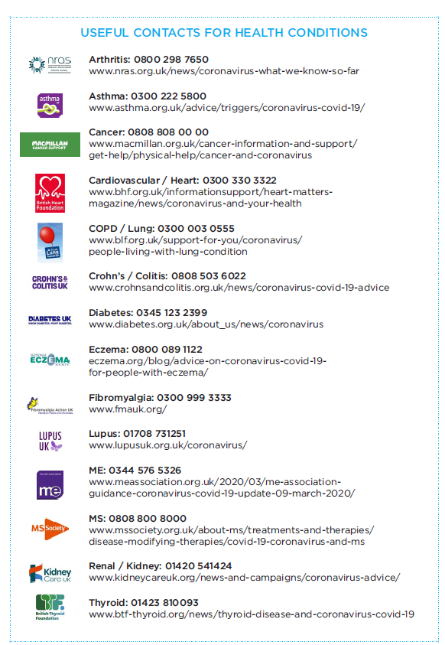
Coronavirus – Concern about isolation of family members

Concern about isolation of family members, including elderly relatives and those with vulnerabilities meaning they have had to self-isolate |  | 
 | Advice and Tips
- Agree with family members how often you’ll stay in touch to ensure that people who are isolated receive regular contact either over the phone or online;
- Check with those self-isolating whether they have all the food and supplies that they need; if not offer to help – you can drop off groceries at the door, or order an online delivery through one of the main supermarkets;
- If you know your family members neighbours, see if they can help keep an eye on your relative;
- Create an emergency plan in case you become ill and are unable to look after your family member. The plan should include details of medication required, contact details and details of anyone else who can step in if you are unwell;
- Encourage your family member to stay active. Even if they don’t have a garden they should ensure that they move about regularly rather than sitting for long periods;
- Make sure that anyone who has to visit your family member, such as carers or home help, washes their hands properly before and after their visit;

 | Relevant Support Services
COVID 19 Mutual Aid groups – these are springing up around the UK, set up by individuals to provide support to those self-isolating. Details of those in North Wales are in the document below which includes the link to the UK list. Please note that none of these groups have been officially verified in any way.
Neighbourhood Watch - Find out if your area, or the area that your family members live in, have a Neighbourhood Watch Scheme as this is a useful way for neighbours to stay in touch and look out for one another https://www.ourwatch.org.uk/get-involved/find-my-local-neighbourhood-watch/
Carers Trust North Wales – provides emotional and practical support to unpaid carers in North Wales (01492 542212 or http://www.nwcrossroads.org.uk/)
Carers Outreach Service North Wales – provides help and support for unpaid adult carers (01248 370797 or https://www.carersoutreach.org.uk/index.html)
Age UK Cymru – support groups and information. https://www.ageuk.org.uk/cymru/

Coronavirus – Support with finances
1. Support about finances, especially if members of your family are self-employed or work in an industry directly affected by coronavirus (e.g. leisure, hospitality) |  | 
 | Advice and Tips
- Review areas of spending where you might be able to reduce costs such as tariffs for electricity / gas / TV / phone / broadband. If any insurance is due for renewal, look around for cheaper quotes;
- Take advantage of sites such as MoneySavingExpert.com;
- If you have difficulty paying your monthly costs, you may be able to agree some flexibility with paying your council tax – phone 01286 682706 for North Wales;
- Anyone who is self-employed and has to stop work due to coronavirus can now get statutory sick pay from day one as long as they usually earn at least £118 a week;
- Read the factsheet ‘Making Ends Meet’ downloaded from gingerbread.org.uk to get more advice and tips:
Homeworking Tax Relief £

Did you know that if you have been asked to work from home then you can claim tax relief? To find more information go to the government site:
https://www.gov.uk/tax-relief-for-employees/working-at-home

 | Other relevant Support Services
Money Advice Service – Free and impartial money advice including debt, budgeting and benefit (https://www.moneyadviceservice.org.uk/) and now available is a specific page to support you during COVID19: https://www.moneyadviceservice.org.uk/en/categories/coronavirus-information
National Debt Line – free debt advice online through mymoneysteps.org
Food Banks – there are several food banks in North Wales who help those in crisis and unable to afford food. Many of these are run by The Trussell Trust and you will need a voucher to obtain food, which you can get from a Citizens Advice Bureau. Details of food banks in North Wales:
- Conwy Food Bank (01492 471793)
- Abergele District Food Bank (01745 826570)
- Flintshire Food Bank (01352 757235)
- Anglesey Food Bank (07557 333498)
- Arfon Foodbank Caernarfon (07482 235754)
- Barmouth Foodbank (07973 914599)
- Wrexham Foodbank (07538 547971)
- Holyhead Foodbank (01407 764947)

Coronavirus – Support with illness or bereavement
Support with illness or bereavement in your family |  | 
 | Advice and Tips
Illness of you or your family:
- If you suspect that you or your family have Coronavirus then follow this link https://phw.nhs.wales/topics/latest-information-on-novel-coronavirus-covid-19/what-to-do-if-you-have-symptoms-of-coronavirus/.

Bereavement:

Following a bereavement, you might experience any of the feelings below:
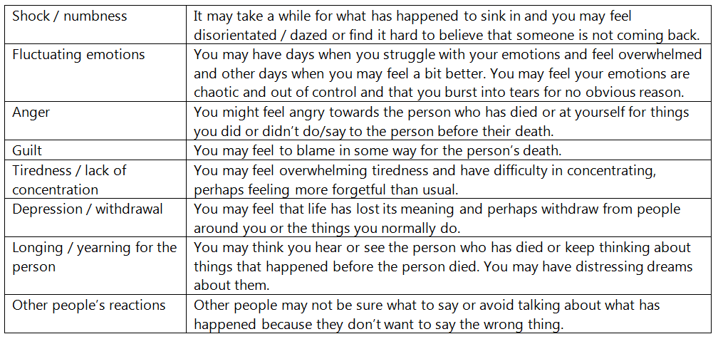

Suggestions that may help:
- Acknowledge your pain and understand there are stages to your grief.
- Don’t bottle up feelings – express emotions in an appropriate environment;
- Understand that your grieving process will be unique to you and let yourself grieve;
- Seek support from people who care about you and talking about what has happened;
- Don’t expect memories to fade immediately;
- Do take time to rest and be with family and friends;
- Do remain fit and active and take care of your physical health;
- Do try and keep your life as normal as possible following a bereavement;
- Do take a balance between work and home life;
- Move forward with your life using your memories to define the person you are and focus on the positive aspects of your life.

Signs that you may need help to move on: If you are experiencing the following feelings and they continue for a long period of time:
- You can’t get out of bed;
- You neglect yourself or your family e.g. you don’t eat properly;
- You feel you can’t go on without the person you have lost;
- The emotion is so intense that it’s affecting the rest of your life e.g. you can’t face going to work, or take your anger out on others.

Further advice on bereavement:
We have downloaded a guide to bereavement from MIND which may also help:

Funeral guidance during the COVID19 period:

During the COVID19 lockdown period there are various rules in place about funerals. You can read the Welsh Guidance in the document below and key points are covered in the FAQ’s below.

FAQ’s:
Q: How many people can attend the funeral?
A: People should only attend the funeral of their closest family and friends, and only if they have been invited. People are also encouraged not to attend a funeral if doing so would involve extensive travel. In accordance with separate Welsh Government guidance, those experiencing coronavirus symptoms or are self-isolating should not attend. In addition those considered most vulnerable to the coronavirus should be encouraged not to attend.

Anyone attending must keep to the prescribed social distance of 2 metres (except between two members of the same household, or a carer and the person assisted by the carer) and the venue for the funeral may need to place a restriction on the numbers that can attend to ensure that this rule can be applied effectively. Social distancing also applies within a cemetery after any service.

There are alternatives available to consider. These include:
- A ‘streamed’ online ceremony that people can attend in real time.
- Recording of the ceremony on video and audio to provide for dissemination at the family and force discretion.
- Direct cremation with a memorial ceremony at a future date. Cremated remains could be retained and interred at a future date. Either of these events could well be a considerable time forward.

Q: Can we have a memorial book?
A: You might want to consider opening a book of condolence ‘online’. There are various organisations offering this service such as https://www.remembranceonline.co.uk/ or https://www.remembr.com/en.

Q: How can I help myself having to self-isolate and not have the opportunity to spend time with the person to say goodbye?
A: This is a difficult time to accept reality of the bereavement and you may experience feelings of angst, distress, anger and guilt. Talking things through with family and friends can be comforting and can be done remotely using phone social media and text

Q: How can I involve people who can’t go to the funeral?
A: There may be family and friends who aren’t able to go to the funeral due to the current rules or their personal situation. This might be very difficult for them and they may understandably be upset about this. For many people, going to a funeral is an important part of their grieving process.
Here are some ideas about ways you can include people who can’t attend:
- Send them details of any music, poems or readings from the funeral so they can listen to them or read them in their own time.
- Play a recorded message from them or read some words on their behalf.
- Light a candle or lay flowers on behalf of the person who is unable to attend.
- Read the names of people who would like to have attended but weren’t able to.
- Ask people to share their memories of the person – they could send letters, photos, favourite songs or recorded messages.
- Create a virtual memorial book where people can leave messages.
- You might want to take pictures, record the funeral or live stream it. Some funeral directors may be able to help you with this.
- Ask people to do something at the time of the funeral such as lighting a candle, praying or having a moment of reflection.
- Offer to hold a gathering at a later date to bring everyone together to remember the person together.
You may not feel able to do these things and that’s OK too. Remember that it’s a difficult time for you as well – you are grieving for someone you cared about. You could see if another family member or friend would be able to help with these things.

Remembrance service or gathering at a later date
You may want to think about organising a remembrance service or gathering at a later date. This can help bring everyone together, support each other and say goodbye to the person. You might want to have a religious ceremony, service or wake. You might choose to do something less formal, like going for a walk, meeting in their favourite place or going out for a meal.
There is a lot of uncertainty at the moment, so it may be sensible not to choose a specific date. It’s also important to wait until the government advises that it’s safe to have a service or gathering. But even just knowing that you will do something and sharing ideas for it may be comforting.
Q: How you might feel if you can’t go to the funeral
A: If you can’t go to a funeral of someone you cared about, this can be very upsetting. For many people, funerals are an important part of their grieving process. You might feel:
- annoyed, angry or frustrated that you’re unable to go to something so important
- undervalued or ignored if you aren’t considered someone’s immediate family but you still had a very close relationship with them
- supported if people have tried to involve you in some way
- sad that you are missing an important part of saying goodbye
- lonely or isolated as you’re unable to share your grief with others and get support
- worried about not having closure and how this will affect your grief
- guilty if you are unable to attend because of your personal circumstances, even if this is not your fault.
You may also feel annoyed towards the people who can go to the funeral. This is an understandable feeling to have. Try to remember that they are also experiencing a loss and things may be hard for them too.
These are feelings you might have as well as your feelings of grief and loss for the person who has died. This is understandably a very difficult situation for you to be in. It may also be hard to accept, as rules on who can and can’t attend funerals have changed so recently.
These are all very normal feelings to have, given the circumstances. There are other ways you can say goodbye and get support during this time – we have some things that could help below.
You could ask someone who is going to the funeral if there are ways that you could be involved even though you can’t attend. We have some ideas above about involving people who can’t go to the funeral.
You might want to find your own way of remembering the person and saying goodbye. We know that this won’t be the same as going to the funeral, but it may still help. Here are some ideas about what you could do:
- Take some time to reflect on your relationship with the person – you might want to light a candle, look at photos, listen to music that reminds you of them, write down your memories or draw a picture.
- Speak to other people about the person who died – it may help to share memories together.
- Make a donation to a charity in their name.
- Create a memory book or video to reflect on your loved one’s life. You could create something physical, like a book or box, or create something online that can be shared with other family and friends.
- Plan for things you might be able to do in the future, like planting a tree in their memory or visiting a place that was special to your relationship.
Q: Where can I get support?
A: You might have a lot of different feelings about the person dying and about not being able to say goodbye as you would have wanted to. Try to remember that this is not your fault. Many of these things are outside of your control.
Reducing contact with other people is the best way to stop coronavirus from affecting more people. Try to recognise the feelings that you are having and understand that these are a normal response to very difficult circumstances.

Support from family and friends
It may help to talk to someone about how you’re feeling. You could talk to other family or friends. They might have similar thoughts and feelings.
It may also help to talk to someone who isn’t in the same situation, like a friend who didn’t know the person who died so well. Further signposting to support is provided in the next section below.

 | Relevant Support Services
Cruse Bereavement Care - Provide a UK Freephone helpline if you need to talk after the death of someone close. Phone 0808 808 1677. Lines open 9:30am - 5:00pm on Monday and Friday and 9:30am – 8:00pm on Tuesday, Wednesday and Thursday. They also offer face to face group support by trained bereavement volunteers.
There is a branch of Cruse in North Wales (27 Princes Drive, Colwyn Bay) Contact details: www.crusenorthwalesarea.btck.co.uk / Telephone: 01492 536 577 / Email: northwales@cruse.org.uk

